***ANUDIP FOUNDATION***

A Project Report on

**“ONLINE SHOPPING SYSTEM”**

By

Batch: ANP-C7344

Student ID: AF0376349

Name: Pranali Sandupatla

**Under the Guidance of**

Mrs. Rajshri Chandrabhan Thete

ONLINE SHOPPING SYSTEM

A Shopping Management System (SMS) is designed to enhance the online shopping experience by utilizing advanced algorithms to analyze user preferences, purchase history, and real-time trends. By integrating various functionalities such as customer management, product cataloging, order processing, and personalized recommendations, the system streamlines the entire shopping process. This not only helps users discover and explore products that match their tastes and preferences but also optimizes the operational efficiency for retailers. With features like customer sessions, cart management, and order tracking, the Shopping Management System ensures a seamless and engaging shopping experience for users while providing valuable insights for businesses to enhance their service offerings.

**Entities:**

* Address
* Admin
* Cart
* Customer
* Order
* Product
* User
* Payment

**VARIOUS ENTITIES:**

1. **Address**

* address_id (int, Primary Key)
* city (varchar(255))
* country (varchar(255))
* pincode (varchar(255))
* state (varchar(255))
* street_no (varchar(255))

1. **Admin**

* admin_id (int, Primary Key)
* email (varchar(255))
* name (varchar(255))
* mobile_number (varchar(255))
* password (varchar(255))

1. **Cart**

* cart_id (int, Primary Key)
* customer_customer_id (int, Foreign Key)

1. **Customer**

* customer_id (int, Primary Key)
* email (varchar(255))
* name (varchar(255))
* mobile_number (varchar(255))
* password (varchar(255))
* address_address_id (int, Foreign Key)

1. **Order**

* order_id (int, Primary Key)
* location (varchar(255))
* order_date (date)
* total (double)
* address_address_id (int, Foreign Key)
* customer_customer_id (int, Foreign Key)

1. **Product**

* product_id (int, Primary Key)
* cart_id (int)
* category_name (varchar(255))
* colour (varchar(255))
* dimension (varchar(255))
* price (double)
* product_name (varchar(255))
* quantity (int)
* specification (varchar(255))

1. **User**

* id (varchar(255), Primary Key)
* password (varchar(255))
* role (varchar(255))

       8.  **Payment**

* payment_id(int)
* payment_date(date)
* payment_method (varchar(255))
* amount(decimal)

**ER DIAGRAM FOR ONLINE SHOPPING SYSTEM:**

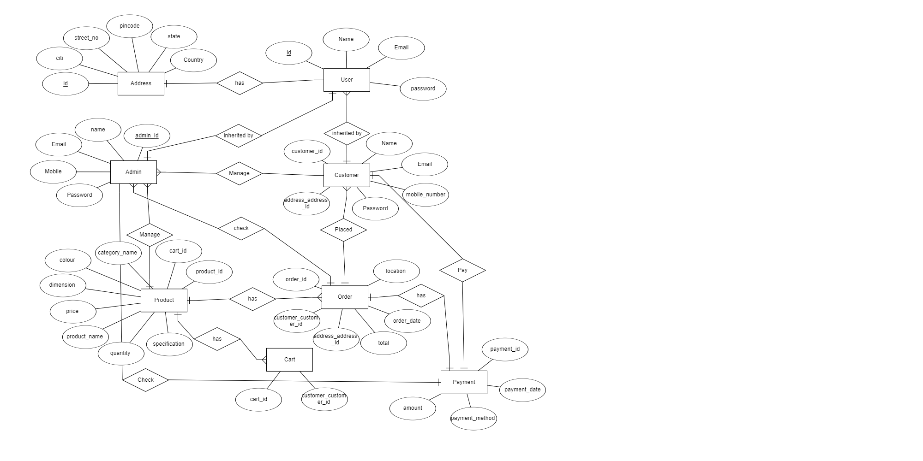

**DATABASE :**

CREATE DATABASE Online_Shopping_System;

USE Online_Shopping_System;

CREATE TABLE address (

address_id INT AUTO_INCREMENT PRIMARY KEY,

building_name VARCHAR(255),

city VARCHAR(255),

country VARCHAR(255),

pincode VARCHAR(255),

state VARCHAR(255),

street_no VARCHAR(255)

);

CREATE TABLE admin (

admin_id INT AUTO_INCREMENT PRIMARY KEY,

email VARCHAR(255),

first_name VARCHAR(255),

last_name VARCHAR(255),

mobile_number VARCHAR(255),

password VARCHAR(255)

);

CREATE TABLE cart (

cart_id INT AUTO_INCREMENT PRIMARY KEY,

    customer_customer_id INT,

FOREIGN KEY (customer_customer_id) REFERENCES customer(customer_id)

);

CREATE TABLE current_admin_session (

current_session_id INT AUTO_INCREMENT PRIMARY KEY,

admin_id INT,

`key` VARCHAR(255),

local_date_time DATETIME(6),

FOREIGN KEY (admin_id) REFERENCES admin(admin_id)

);

CREATE TABLE current_customer_session (

current_session_id INT AUTO_INCREMENT PRIMARY KEY,

customer_id INT,

`key` VARCHAR(255),

local_date_time DATETIME(6),

FOREIGN KEY (customer_id) REFERENCES customer(customer_id)

);

CREATE TABLE current_user_session (

current_session_id INT AUTO_INCREMENT PRIMARY KEY,

customer_id INT,

`key` VARCHAR(255),

local_date_time DATETIME(6),

FOREIGN KEY (customer_id) REFERENCES customer(customer_id)

);

CREATE TABLE customer (

customer_id INT AUTO_INCREMENT PRIMARY KEY,

email VARCHAR(255),

first_name VARCHAR(255),

last_name VARCHAR(255),

mobile_number VARCHAR(255),

password VARCHAR(255),

address_address_id INT,

FOREIGN KEY (address_address_id) REFERENCES address(address_id)

);

CREATE TABLE `order` (

order_id INT AUTO_INCREMENT PRIMARY KEY,

location VARCHAR(255),

order_date DATE,

order_status VARCHAR(255),

total DOUBLE,

address_address_id INT,

    customer_customer_id INT,

FOREIGN KEY (address_address_id) REFERENCES address(address_id),

FOREIGN KEY (customer_customer_id) REFERENCES customer(customer_id)

);

CREATE TABLE order_product_dto_list (

order_order_id INT,

colour VARCHAR(255),

dimension VARCHAR(255),

manufacturer VARCHAR(255),

price DOUBLE,

product_id INT,

product_name VARCHAR(255),

quantity INT,

PRIMARY KEY (order_order_id, product_id),

FOREIGN KEY (order_order_id) REFERENCES `order`(order_id),

FOREIGN KEY (product_id) REFERENCES product(product_id)

);

CREATE TABLE cart_products (

cart_cart_id INT,

colour VARCHAR(255),

dimension VARCHAR(255),

manufacturer VARCHAR(255),

price DOUBLE,

product_id INT,

product_name VARCHAR(255),

quantity INT,

PRIMARY KEY (cart_cart_id, product_id),

FOREIGN KEY (cart_cart_id) REFERENCES cart(cart_id),

FOREIGN KEY (product_id) REFERENCES product(product_id)

);

CREATE TABLE customer_list_of_orders (

    customer_customer_id INT,

    list_of_orders_order_id INT,

PRIMARY KEY (customer_customer_id, list_of_orders_order_id),

FOREIGN KEY (customer_customer_id) REFERENCES customer(customer_id),

FOREIGN KEY (list_of_orders_order_id) REFERENCES `order`(order_id)

);

CREATE TABLE product (

product_id INT AUTO_INCREMENT PRIMARY KEY,

cat_id INT,

category_name VARCHAR(255),

colour VARCHAR(255),

dimension VARCHAR(255),

manufacturer VARCHAR(255),

price DOUBLE,

product_name VARCHAR(255),

quantity INT,

specification VARCHAR(255)

);

CREATE TABLE user (

id VARCHAR(255) PRIMARY KEY,

password VARCHAR(255),

role VARCHAR(255)

);

**CONCLUSION:**

In conclusion, online shopping has revolutionized retail, offering unparalleled convenience but also posing challenges like cybersecurity threats. Despite these challenges, the future of online shopping looks promising with advancements in technology. To stay competitive, businesses must adapt to evolving consumer preferences and prioritize security measures.

.